|  |
| --- |
|  |
| **Afrem Dilmac**  **r0833187**  **1TI2** |
| Eerste Bachelor - Toegepaste Informatica  Choose an item. |
|  |
|  |
| **Routing, Switching & Wireless**  Peter De Vos |
|  |
| Academiejaar 2020-2021 |

|  |  |
| --- | --- |
| [RS&W Opdracht 2] | |
| [ module 4 deel 1] |

Inhoudstabel

1. 4.2.7 Packet Tracer - Configure Router-on-a-Stick Inter-VLAN Routing 3

1. 4.2.8 Lab - Configure Router-on-a-Stick Inter-VLAN Routing 4

2. 4.3.8 Packet Tracer - Configure Layer 3 Switching and Inter-VLAN Routing 5

3. 4.8 Packet Tracer - Troubleshoot Inter-VLAN Routing 6

4. 4.4.9 Lab - Troubleshoot Inter-VLAN Routing 7

# 4.2.7 Packet Tracer - Configure Router-on-a-Stick Inter-VLAN Routing

Part 1: Add VLANs to a Switch

Step 1: Create VLANs on S1.

Create VLAN 10 and VLAN 30 on S1.



**Vlan 10 en 30 zijn hier aangemaakt.**

Step 2: Assign VLANs to ports.

a. Configure interfaces F0/6 and F0/11 as access ports and assign VLANs.

• Assign the port connected to PC1 to VLAN 10.

• Assign the port connected to PC3 to VLAN 30.

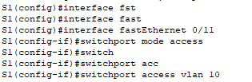

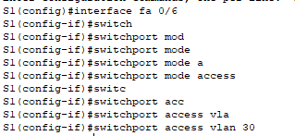

**Hier configureer ik de fo/6 en de fo/11 en toewijs ik pc1 aan vlan10 en pc3 aan vlan30.**

b. Issue the show vlan brief command to verify VLAN configuration.

S1# show vlan brief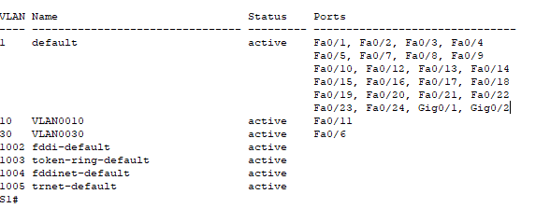

Hier kan men zien dat Vlan10 aangebonden is aan fa0/11 en vlan30 aan fa0/6.

Step 3: Test connectivity between PC1 and PC3.

From PC1, ping PC3.

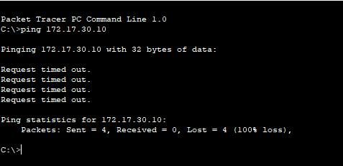

Hier heb ik de ip address van PC3 genomen en hiermee in de command prompt van PC1 een ping commando uitgevoerd.

Were the pings successful? Why did you get this result?

Hier werkt het niet omdat ze beide niet in dezelfde vlan zijn.

Part 2: Configure Subinterfaces

Step 1: Configure subinterfaces on R1 using the 802.1Q encapsulation.

Open configuration window

a. Create the subinterface G0/0.10.

• Set the encapsulation type to 802.1Q and assign VLAN 10 to the subinterface.

• Refer to the Address Table and assign the correct IP address to the subinterface.

R1(config)# int g0/0.10

R1(config-subif)# encapsulation dot1Q 10

R1(config-subif)# ip address 172.17.10.1 255.255.255.0

b. Repeat for the G0/0.30 subinterface.

Step 2: Verify Configuration.

a. Use the show ip interface brief command to verify subinterface configuration. Both subinterfaces are down. Subinterfaces are virtual interfaces that are associated with a physical interface. Therefore, in order to enable subinterfaces, you must enable the physical interface that they are associated with.

b. Enable the G0/0 interface. Verify that the subinterfaces are now active.

Part 3: Test Connectivity with Inter-VLAN Routing

Step 1: Ping between PC1 and PC3.

Question:

From PC1, ping PC3. The pings should still fail. Explain.

Step 2: Enable trunking.

Open configuration window

a. On S1, issue the show vlan command.

Question:

What VLAN is G0/1 assigned to?

b. Because the router was configured with multiple subinterfaces assigned to different VLANs, the switch port connecting to the router must be configured as a trunk. Enable trunking on interface G0/1. How can you determine that the interface is a trunk port using the show vlan command?

c. Issue the show interface trunk command to verify that the interface is configured as a trunk.

Step 3: Test Connectivity

If the configurations are correct, PC1 and PC3 should be able to ping their default gateways and each other.

Question:

What addresses do PC1 and PC3 use as their default gateway addresses?

# 4.2.8 Lab - Configure Router-on-a-Stick Inter-VLAN Routing

# 4.3.8 Packet Tracer - Configure Layer 3 Switching and Inter-VLAN Routing

# 4.8 Packet Tracer - Troubleshoot Inter-VLAN Routing

# 4.4.9 Lab - Troubleshoot Inter-VLAN Routing